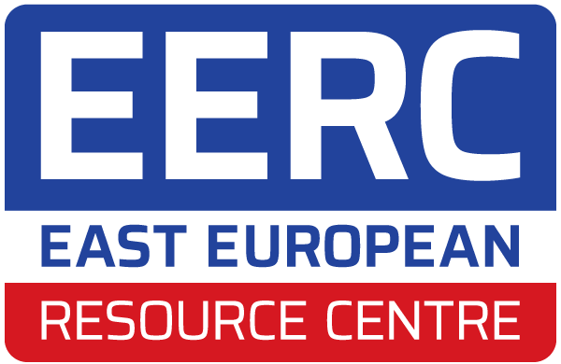
Immigration Adviser
Job description and person specification
Job details
Role Title: Immigration Adviser
Salary: £28,562 - £35,128 per annum pro rata
Hours: Full time
Contract: Temporary contract – six months
Location: London
KEY INFORMATION
East European Resource Centre (EERC) is seeking a Ukrainian-speaking Immigration Adviser to join our fantastic team.
The successful candidate will already have accreditation with the Immigration Advice Authority (IAA) (formerly OISC) to Level 1, 2, or 3.
Please note - EERC welcomes applications from candidates who don’t meet this requirement. We are open to hiring an Immigration Assistant who has some relevant skills and experience but no accreditation. We are also open to hiring a solicitor accredited in Ukraine who wishes to work towards dual accreditation. The pay is linked to the accreditation level.
The role will focus on providing immigration outreach campaign and advice and casework to Ukrainian people in the UK. Outreach encompasses developing key information resources for digital distribution and in-person engagement with members of Ukrainian community through events, workshops, drop-ins across Greater London.
This role is full time. The initial contract is for six months, it may be possible to extend depending on funding.
This role can be done entirely from our office or in a hybrid between office and work from home. There is likely to be some planned evening and weekend work to attend outreach and events.
How to apply – Please complete application form online and submit by the deadline. Application form here: https://forms.office.com/e/3bZuY0FaEE
Deadline – 10am on Monday 7 April

Background
EERC is an independent charity that has been providing advice and support to disadvantaged Eastern European migrants since 1984. Since the 2004 / 2007 EU enlargement, our core user group comes from the accession countries: Poland, Romania, Lithuania, Moldova, Slovakia, Czechia, Hungary, Bulgaria, Latvia, Estonia, and Slovenia. EERC has also extended our services to Ukrainian, Russian, and Belarusian people.
Our history started in 1981 when as a Polish Refugee Rights Group we initiated support to Polish refugees in London after the Martial Law and persecution of Poles involved in the Solidarity movement. As the Iron Curtain started to crumble, the need to support fleeing nationals from the Soviet Bloc encouraged us to expand our areas of help and we became the East European Advice Centre. Our history mirrors history of Central Europe, with waves of refugees from the Balkan wars, fleeing persecuted Roma communities and economic migrants from transforming Central European countries having shaped our work. In recognition of diversified portfolio of services and multiple needs of our constituents, we changed the name to EERC in 2015.
We help all Eastern European migrants in need but our core focus is on those who are disadvantaged, marginalised and isolated. We work with users who are socially excluded or at risk; who are impoverished and those who are victims of hate crime, domestic violence, and modern slavery; who have low life skills, are illiterate, and have no support networks. Our work combines frontline delivery of services with continuous needs assessment so that we can respond to new emerging needs, or needs specific to particular vulnerabilities of our users.
Each year we help over 2,000 people through our client services. We’ve reached a further 1 million people through online events and campaigns. Currently, we provide:
- Advice and casework covering welfare benefits, housing, and immigration
- Independent advocacy and holistic support for survivors of domestic violence and hate crime
- Outreach and awareness-raising campaigns to reach even the most marginalised fellow expats
EERC is a fully professional organisation. We are members of Advice UK, National Homeless Advice Service, Children Poverty Action Group and many other networks. We are registered with the Office of Immigration Services Commissioner. EERC is a charitable company limited by guarantee registered with Companies House and the Charity Commission (1114607.)

EERC Values
- We are compassionate and empathetic with clients and colleagues.
- We act and operate with honesty, integrity, and transparency.
- We are inclusive and reach out to marginalised and isolated people.
- We seek to empower clients and communities.
- We offer a professional service with appropriate boundaries.
- We prioritise staff wellbeing in our structures, systems, and culture.
- We have positive impact and make a difference in all our work.

working for eerc
EERC is a dynamic and fulfilling place to work. Our staff are committed, skilled and resourceful. We work in strong and supportive teams. We strive to be an inclusive and ambitious employer and invest in staff development and benefits. This includes:
- Competitive and transparent pay structure;
- Annual incremental pay increases after two years;
- Generous holiday allowance starting with 33 days of annual leave and rising annually by 1 day after two years to maximum of 38 days of annual leave;
- Employee assistance programme including access to counselling; and,
- Training and accreditation.
EERC has 30 staff. We are a team of advisers, solicitors, and support staff, who all play an important role in delivering our work. All staff are a member of a programme team and have a line manager. This role will report to the Immigration Solicitor.

ROLE DESCRIPTION
1. PURPOSE:
To provide outreach and contribute to information resources; and to provide high quality advice and casework around immigration law.

2. KEY DUTIES AND RESPONSIBILITIES
2.1 Immigration Advice and Casework
- Maintain an understanding of the social, legal, and regulatory context and needs of user group in and around the advice area.
- Provide high quality free and charged immigration advice and casework to clients.
- Balance and maintain an active caseload.
- Keep all support plans and interactions up-to-date using EERC’s case management software and in line with EERC policies.
- Take part in casework supervision including regular file reviews and casework discussion meetings.
- Conduct regular file reviews of colleague’s casework to ensure high quality advice given and procedures followed if required.
- Uphold and adhere to EERC policies to safeguard users and colleagues against breach of confidentiality, poor practice, abuse, conflicts of interest, and other risks.

2.2 Outreach and information
- Develop and provide outreach services to vulnerable Eastern Europeans including workshops and drop in surgeries in various locations around London.
- Develop fact sheets, blogs, and other learning materials with relevant and accessible information about the advice area for sharing online and in print.

2.3 General
- Adhere to and uphold EERC’s policies and procedures and relevant legislation and regulations.
- Maintain accurate monitoring data through EERC’s case management software and other tools as required.
- Contribute to reporting – drawing out data, narratives and case studies – when needed.
- Support colleagues to promote individual, team and organisation wellbeing.
- Take an active role in EERC, attending meetings and supporting the development of the service.
- Work flexibly as required by the support service and to undertake any other duties commensurate with the post.
- Liaise with EERC staff to ensure seamless service development and provision.

PERSON SPECIFICATION
The following knowledge, experience and skills are essential for this role.
- Experience and expertise in providing advice and casework on immigration law.
- Experience working with vulnerable and marginalised people.
- Fluency in Ukrainian language – both spoken and written.
- Strong casework skills.
- Excellent interpersonal skills including maintaining professional boundaries.
- Strong time management skills including managing deadlines and balancing casework.
- Good computer literacy.
- Commitment to EERC’s mission and values.
- Available to work some planned evenings and weekends.
The following knowledge, experience and skills are desirable but not essential for this role.
- Accreditation with the Immigration Advice Authority (IAA) or as a Solicitor.
- Understanding of the charity sector.

